AUTOMATIC LIGHT CONTROLLER- (In Home Appliances)

ABSTRACT- Motion sensor lights are lights that turn on automatically when you walk by or when a car drives into the driveway. Motion sensor lights activate by movement within a specific range of the sensor. Many people place them outdoors as security lights; however, they can also be used indoors as regular light fixtures. These lights are becoming increasingly popular as a way to save money on your electricity bill. One of the main reasons people use motion sensor lights is to save money on their electricity bills. With a motion sensor light, you only use electricity when the light is actually required, which can lead to significant savings over time. In addition to saving money, using less electricity helps reduce your carbon footprint. So, if you’re looking for ways to be more eco-friendly, motion sensor lights are a great option. Another benefit of motion sensor lights is that they can make your home or business more secure. If a potential intruder sees that a light comes on automatically whenever someone approaches, they’re more likely to move on to an easier target. So not only can motion sensor lights save you money, but they can also help keep you safe. If you’re looking to save money and be more eco-friendly, motion sensor lights might be a good option. Installing motion sensor lighting around your home or building is a great way to deter from crime and vandalization. All lighting gives some deterrent to vandalization, but the act of a light turning on will bring more attention to a building from afar. It is easy for someone to blend into the shadows of a lit up a building than it is to hide from a motion sensor light. Motion sensor lighting will pinpoint the location of a possible vandal making it harder for them to move around without being spotted.

Introduction

In today’s life, electricity becomes a prior need to people as to enjoy their social activities thus they need enough electricity to carry out their activities. Lighting is very significant to people as it is important to us;day or night. Early in 2014, government had introduced new electricity tariff due to transpire subsidy Rationalisation Programme made by the government as to stop the energy subsidies gradually. Due to this increase of electrical energy production price, it is

becoming more significant in conserving and saving in electrical energy consumption. Electronic system can

be defined as a family of an electronic circuit and component which is designed for completing either simple function or complex function. There are various examples of electronic system such as telecommunication system, computer system and automation system.The existence of the automation systems began from 1500 years ago where they had invented the first water pump for metal working rolling mills. Automatic control is used in various control system such as in utilizing machinery especially in industrial factories where they used a number of boilers, heating treating oven and other applications with minimal involvement of human. The benefits of using automatic in our daily life are it can minimize the involvement of labour works and also it can be used in saving the energy consumption. This is because the automatic control uses the technique of self-moving processes. Lighting system is one of the huge usages in the household where it has been placed in every section of places especially in every room. There are many different types of lighting technologies that are been used for the household such as flourscent light and LED light. The LED lighting can minimize the usage of light because it only utilized 50% from the energy consumption in the household compared to flourscent lighting.

Literature survey

- Soyoung Hwang et al. proposed a remote monitoring and controlling system based on Zigbee networks. Realtime monitoring is implemented with JMF, a multimedia extension API of Java.
- Richu Sam Alex et al. proposed a system that reduces street lighting system power consumption by about 30% compared to conventional designs. The system is fully automated and uses Zigbee so that the control station can analyze all the system's performances.
- Daeho Kim et al. worked on a smart LED lighting system using Infrared and Ultrasonic sensors. They proposed a model that continuously tracks human motion. Output based on human tracking data obtained by these sensors determines the On-Off control of the lights.

3. Design and methodology

The methodology for this project involves designing an automatic light controller using only sensors and analog components to eliminate the need for microcontrollers or digital logic. The system begins with an infrared (IR) emitter and detector pair that senses motion or presence. The signal from the IR detector is processed by an LM358 operational amplifier configured as a comparator, which compares the sensor output against a reference voltage set by a trimmer. When the IR beam is interrupted, the comparator output triggers a CD4017 decade counter or directly drives a BC547 transistor, which in turn activates a 5V SPDT relay to switch the AC light load. Passive components such as resistors, capacitors, and a diode are used for current limiting, filtering, and flyback protection. The entire circuit is assembled on a breadboard for initial testing, followed by transfer to a customized PCB or acrylic sheet for final deployment. Calibration is performed by adjusting the trimmer and sensor alignment to ensure reliable switching under various lighting and motion conditions.
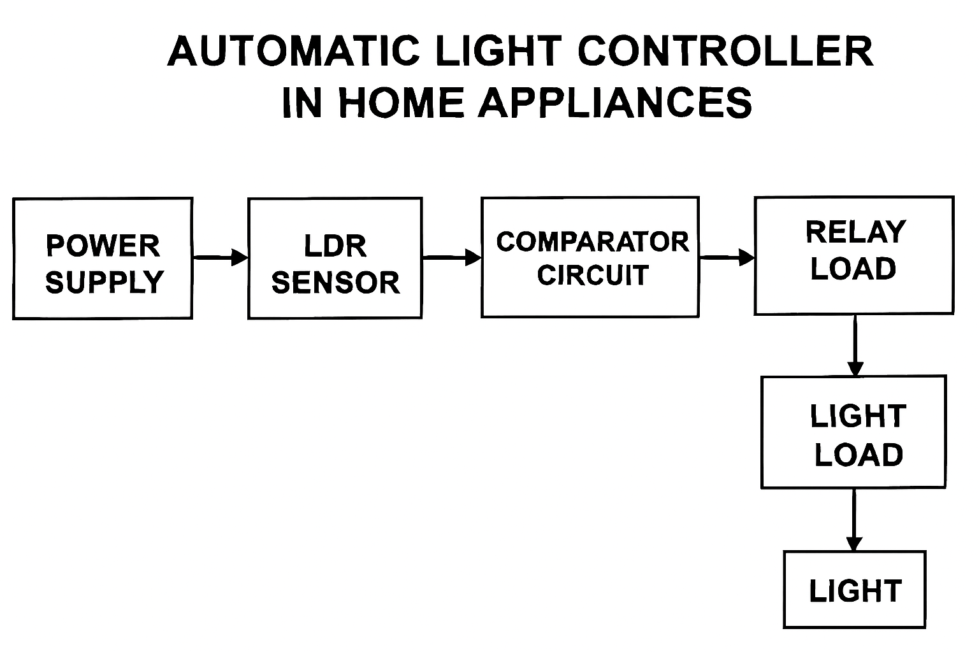

Experimental results

The results of the automatic light controller project demonstrated successful and reliable operation using only sensors and analog components. When the IR beam between the emitter and detector was interrupted by motion or presence, the LM358 comparator produced a high output, triggering the BC547 transistor to activate the 5V SPDT relay. This resulted in the AC bulb switching ON instantly. The system consistently responded to motion within a range of 1–2 meters, with minimal false triggering. The relay operated smoothly without chattering, and the 1N4007 diode effectively suppressed voltage spikes. LED indicators provided clear visual feedback for power and switching status. Overall, the circuit performed as expected under various ambient lighting conditions, validating its suitability for low-cost, microcontroller-free home automation.
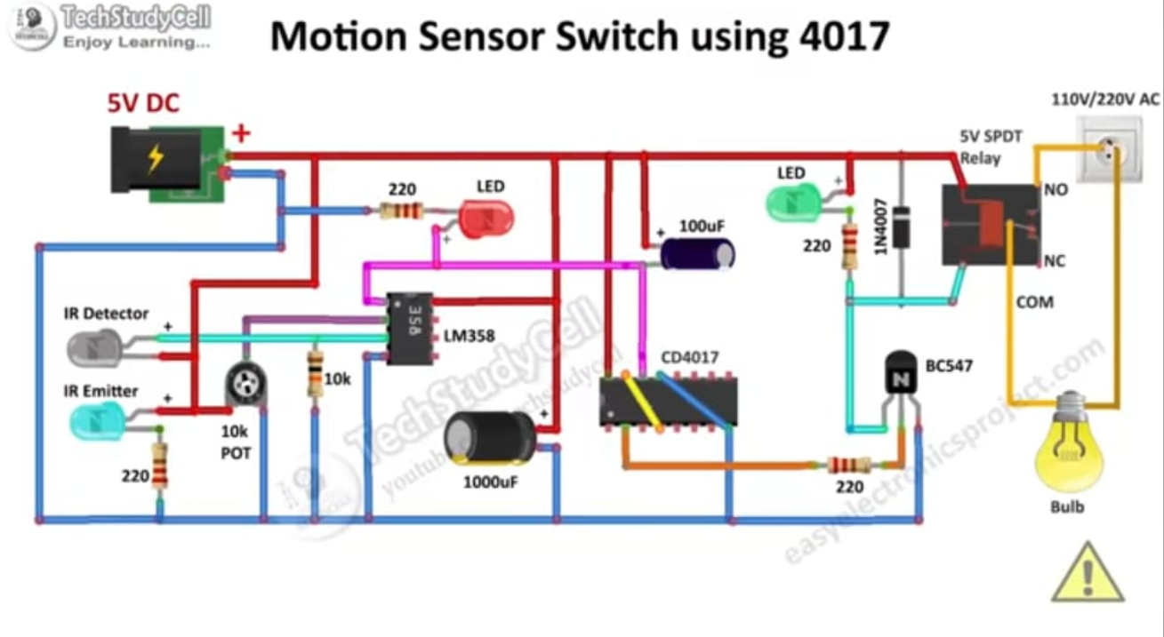

V. Conclusion

Motion sensor lights are a great way to get reliable lighting for your home. Motion sensor lights are a great way to save money as they use less energy than traditional lighting solutions and last much longer, meaning you won’t have to replace bulbs as often. Additionally, motion sensors help reduce your bills by ensuring that the lights turn off when no one is present in the area. Overall, motion sensor lights offer several benefits that make them a great addition to any home or commercial space. Not only are they more energy efficient and secure, but they also offer convenience and cost savings. Motion sensors can be used both indoors and outdoors to make your property safer, provide better lighting, and save you money in the long run. The benefits of motion sensor lights are vast! From enhancing the safety of your home to making it more convenient for everyone, it’s one of the simplest yet smartest home security additions you can make for your home. A motion sensor light is an extremely good energy-saving option which will make your home smart as well. Additionally, when it is dark it can be difficult to find the light switch and this is where motion-sensor lights come in extremely handy. These lights are simple to install and consume very little power

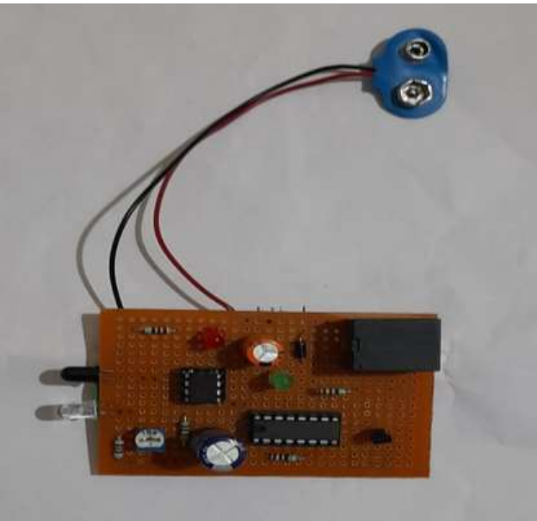

References

1. Soyoung Hwang and Donghui Yu, International Journal of Software Engineering and Its Application, Vol. 6, No. 3, July 2012.
2. Richu Sam Alex, International Journal of Engineering and Advanced Technology (IJEAT), Vol. 3, Issue 4, April 2014.
3. Raja R, Dr. K. Uday Kumar, International Journal of Advanced Research in Electrical, Electronics and Instrumentation Engineering, Vol. 3, Special Issue 2, April 2014.
4.K.Subramanyam, K. Baskar Reddy, P. Ajay Kumar Reddy, International Journal of Engineering Research and Application (IJERA), ISSN: 2248-9622, www.ijera.com, Vol. 3, Issue 4, July–August 2014

